**CNC DPS UPLOAD MACRO**

* Firstly, we need to find our Daily position sheet for all the services from outlook (Generic mailbox CNC).
* We need to open the partner DPS file (4, 5.1, 5.2) from our CNC share point.
* Then we need to copy vessel name from our DPS & search by vessel name & paste the data from Column “C” to” O” in Partner DPS file (4, 5.1, 5.2).

Check Point while uploading DPS are as follow: -

* We need to check the first highlighted green column “D” ATD which should not be after the current date.
* Second call “E” ETD which should not before the current date.
* We need to paste the data till column “O” for all the service.
* Vessel sequence should be as per the latest our DPS.
* We need to put **outside border** from column “C” to “O”
* We need to put **Thick outside border** from Column “A” to “O”

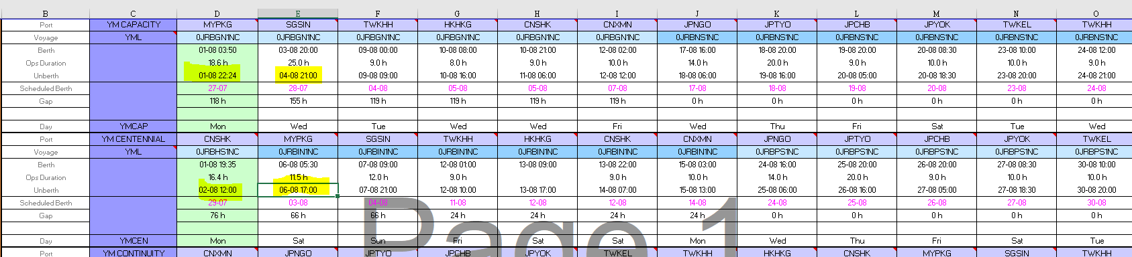

Below further information for your reference: -

4.0 Folder – 9 services DPS

5.1 Folder – 13 Services DPS

5.2 Folder – 10 Services DPS

Share point Link: -

https://cmacgmgroup.sharepoint.com/sites/CMA-CNC-SGP-Operation/Shared%20Documents/Forms/AllItems.aspx?id=%2Fsites%2FCMA%2DCNC%2DSGP%2DOperation%2FShared%20Documents%2F07%2E%20Latest%20DPS%2F07%2E%20Latest%20DPS&viewid=89fd8298%2D8dd3%2D4f02%2Daad9%2D664f36ba60b6